**Managing Employees in a Hybrid Work Environment**

**Hybrid work is the new norm!**

We have settled in a post-epidemic environment with the goal of restarting our enterprises after surviving a worldwide pandemic for over two years. After Corona, many organizations moved towards hybrid work model- where employees work on-site and also from their home. There are many advantages to the employees and also the organization they work for like- enhanced relationships, reduced costs and more flexibility.

However, managing employees in hybrid model can be a challenge for the leaders because the traditional management method they used to work in was more comfortable for them. HR Department suffered the most in working remotely, other departments started doing their work virtually but for HR professionals found it quite challenging to keep an eye on their employee’s well-being while working remotely.

**The Positives and Negatives of Hybrid Working-**



The advance tools like AI and machine learning making process little bit easy for HR professionals in this post-pandemic world. Modern HR Tools and Processes helping organizations to ensure their employees well-being.

But here are some approaches leaders can use to manage employees in a hybrid work environment-

**1) Introducing Assistance Departments for HR in Cooperative Platforms-**

Communication is the foundation of every relationship, which helps us to build in tremendous ways and it’s important in a hybrid model. The use of Collaborative Platforms and E-mails by every firm increased. Platforms like- Microsoft Teams, Google Meet, Zoom and Slack.

HR Professionals should communicate regularly and clearly with the employees. Setting deadlines, spend hours, and project milestones are all part of this. Managers must take their time to make sure that everyone in the team, no matter where they are physically located, is on the same page.



By introducing centralized HR Assistance Departments will help employees to convey their thoughts and ideas to a platform. This will also help to optimize HR processes diligently.

**2)** **Establishing Trust and Liberty-**

In the hybrid work model, it’s obvious for employees to feel disconnected with their team and organization. But leaders can reciprocate it by establishing trust and liberty and diversity in thought. HR can be that middleman which covers that bridge between leaders and employees.

Hybrid model means that allowing employees to work in their style and preference. It’s about building that trust that they will manage the work in limited time and perform their best. It will increase job satisfaction and motivation to do the work with accuracy for the organization.



As long as it complies with team requirements and expectations, managers should encourage staff members to customise their work schedules to fit their personal lives. Managers should consciously work to promote inclusion to offset this.

**3) Focus on Results, not Micromanagement-**

Traditional techniques of gauging productivity based on the number of hours performed in the office are no longer applicable in a hybrid work environment.

Managers should evaluate the quality and amount of their employees' production rather than micromanaging their time.

Giving workers the freedom to manage them own activities and outputs can increase their emotions of ownership and drive.

This might entail scheduling meetings at various times to suit various time zones, making sure that remote workers have an equal opportunity to advance in their careers, and actively seeking their opinion throughout debates and decision-making processes.

**4) Microlearning for Workforce Development-**

A recent development in digital learning is microlearning, which enables businesses to teach their staff by giving them little lessons each day. This entails the managers giving the staff daily doses of training materials in manageable portions, requiring them to dedicate no more than 10 minutes each day to training.

Microlearning is becoming more and more popular across all significant businesses as it meets the employees' short attention span needs. They recall more knowledge without becoming fatigued when given lower doses of training material each day. All that's required is a single platform on which you can upload the necessary materials and let your staff members access them whenever it's convenient for them.

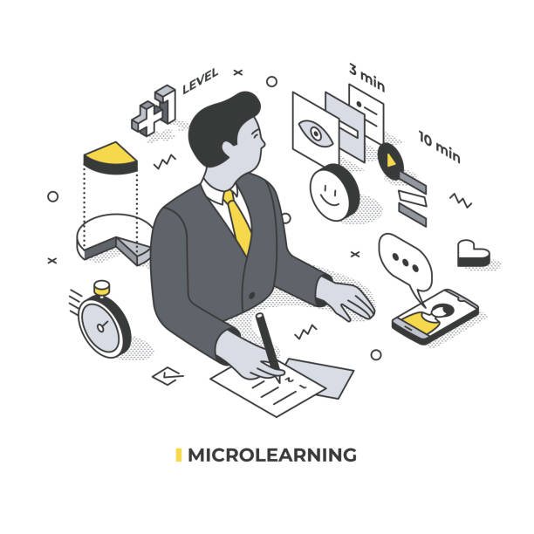

It takes a certain set of abilities to lead a hybrid team. Managers must be adept in remote management strategies, cross-platform digital communication, and virtual environment dispute resolution. Investing in managers' training and development programmes can provide them the skills they need to succeed in this new work environment.

Microlearning is a great way to teach new skills and technology to your staff without subjecting them to protracted training sessions. Additionally, it enables your staff to receive training on their own without the necessity for on-site courses or the engagement of outside trainers. As a consequence, your employees' confidence and morale increase, increasing their level of involvement and productivity inside your company.

**5)** **Increase In Businesses with A Purpose-**

Ambiguity can cause miscommunication and lower productivity in a mixed work setting. Clear guidelines should be provided by managers on expected work hours, availability, delivery dates, and deliverables. Setting these expectations in advance promotes responsibility by assisting both office-based and remote workers in understanding their obligations.

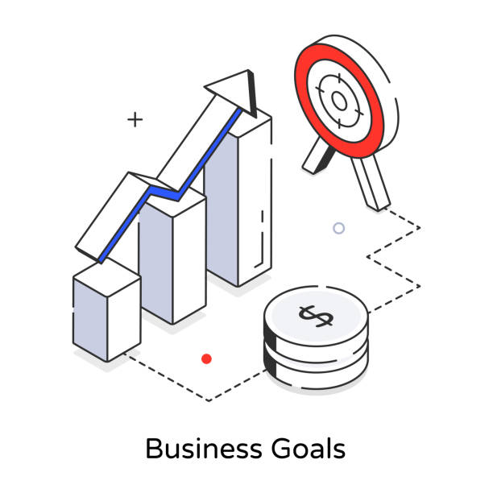

The pandemic issue has caused considerable setbacks for organisations throughout the world, which has led to the emergence of purpose-driven corporations. In this situation, all personnel within an organisation are obligated to work only towards the stated goal. This goal might be to enhance sales, elevate brand value, boost return on investment, reach out to more people, or anything else that the business is prepared to concentrate on.

All HR procedures, discussions, actions, and conduct in purpose-driven firms are focused on achieving a certain goal with the aid of the workforce.

For managers, the hybrid workplace presents both possibilities and problems. Organisations can develop a thriving and effective hybrid work culture by putting a priority on communicating clearly, setting goals, embracing mobility, fostering openness, focusing on outcomes, leveraging technology, offering periodic reviews and feedback, nurturing collaboration, training managers, and keeping an eye on employee well-being. The ability to properly manage people in the current workplace environment will depend on the ability to adapt and improve these techniques as the corporate environment continues to change.